Request 5: Leave mail
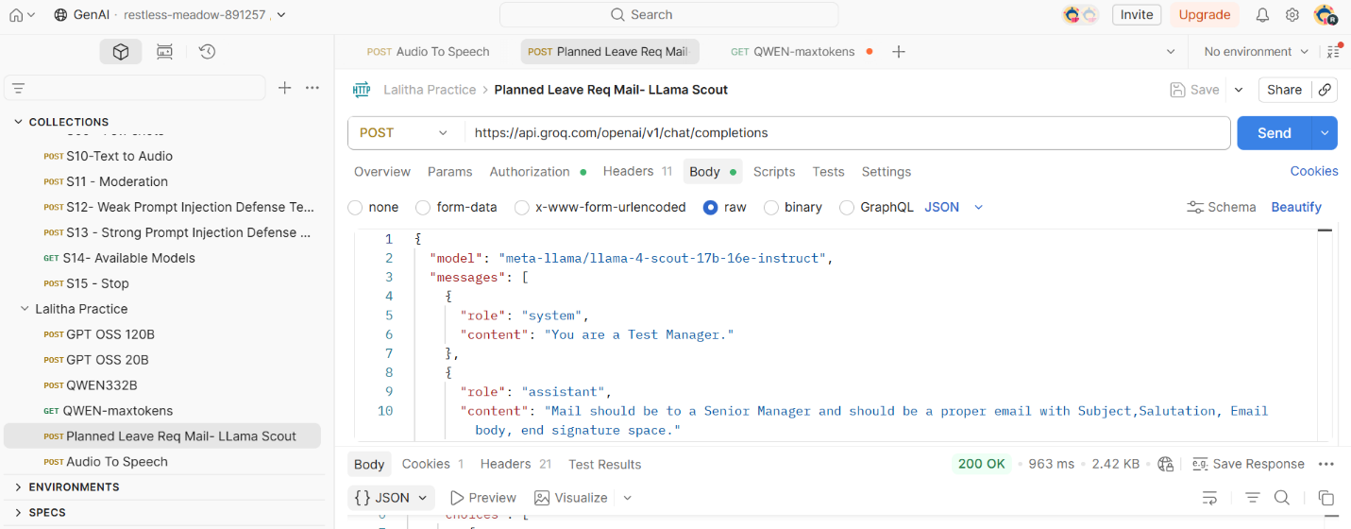
{
"id": "chatcmpl-1a411c1a-a408-411f-a4af-ae62c29d1d33",
"object": "chat.completion",
"created": 1778750336,
"model": "meta-llama/llama-4-scout-17b-16e-instruct",
"choices": [
{
"index": 0,
"message": {
"role": "assistant",
"content": "Here is a professional email for a sick leave request:\n\nSubject: Sick Leave Request for 28th and 29th May\n\nDear [Senior Manager's Name],\n\nI am writing to request a sick leave for two days, 28th and 29th May, as I will be undergoing a minor surgical procedure on 28th May. I anticipate that I will need to take a short period of time to recover and ensure my well-being.\n\nI apologize for any inconvenience this may cause and will ensure that all my tasks are up to date and completed before taking my leave. I will make sure to coordinate with my team to ensure a smooth transition of work during my absence.\n\nPlease let me know if there are any concerns or if there is any additional information required. I appreciate your understanding and approval of my sick leave request.\n\nThank you for your support.\n\nBest regards,\n[Your Name]\nTest Manager\n[Your Contact Information]"
},
"logprobs": null,
"finish_reason": "stop"
}
],
"usage": {
"queue_time": 0.167143937,
"prompt_tokens": 95,
"prompt_time": 0.003221573,
"completion_tokens": 188,
"completion_time": 0.425259867,
"total_tokens": 283,
"total_time": 0.42848144
},
"usage_breakdown": null,
"system_fingerprint": "fp_4221711889",
"x_groq": {
"id": "req_01krjwgadperw810jwa5y0wq2q",
"seed": 547502985
},
"service_tier": "on_demand"
}

Response 6: Added a voice file and got text response.
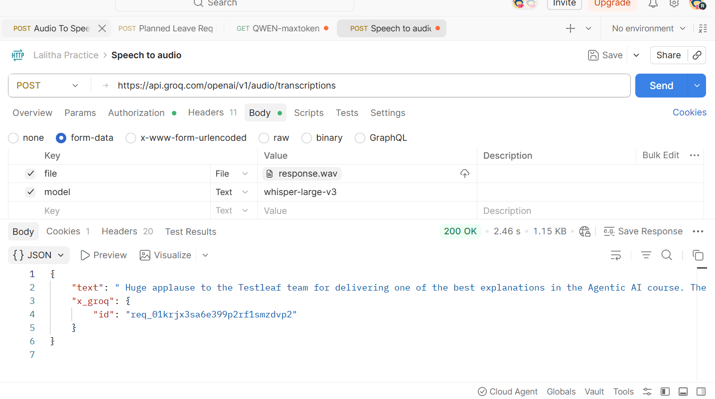
Faced issues below
To enter a proper endpoint url
Learnt how to add voice file & model. Understood that speech to text model should have a mandatory field “model” and the value should be copied from groq.

Request 7: 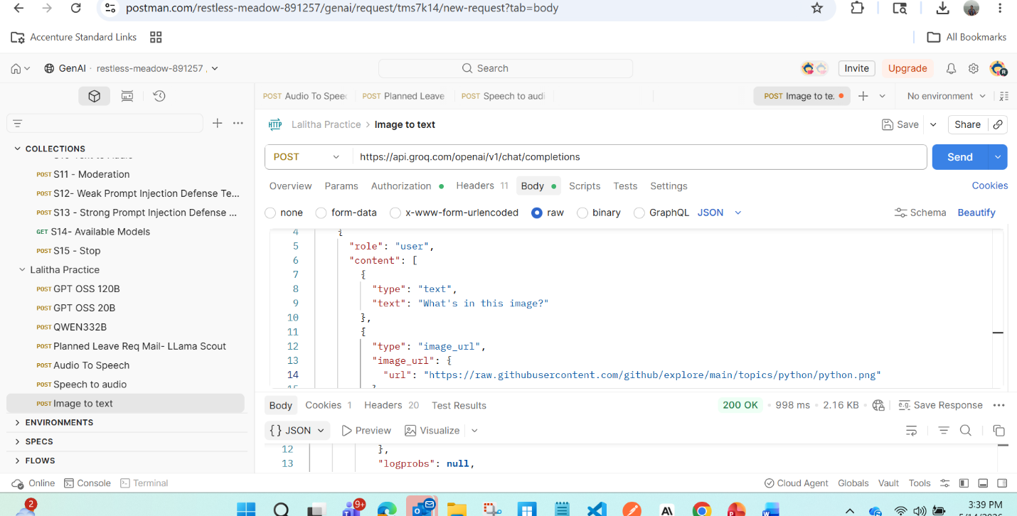
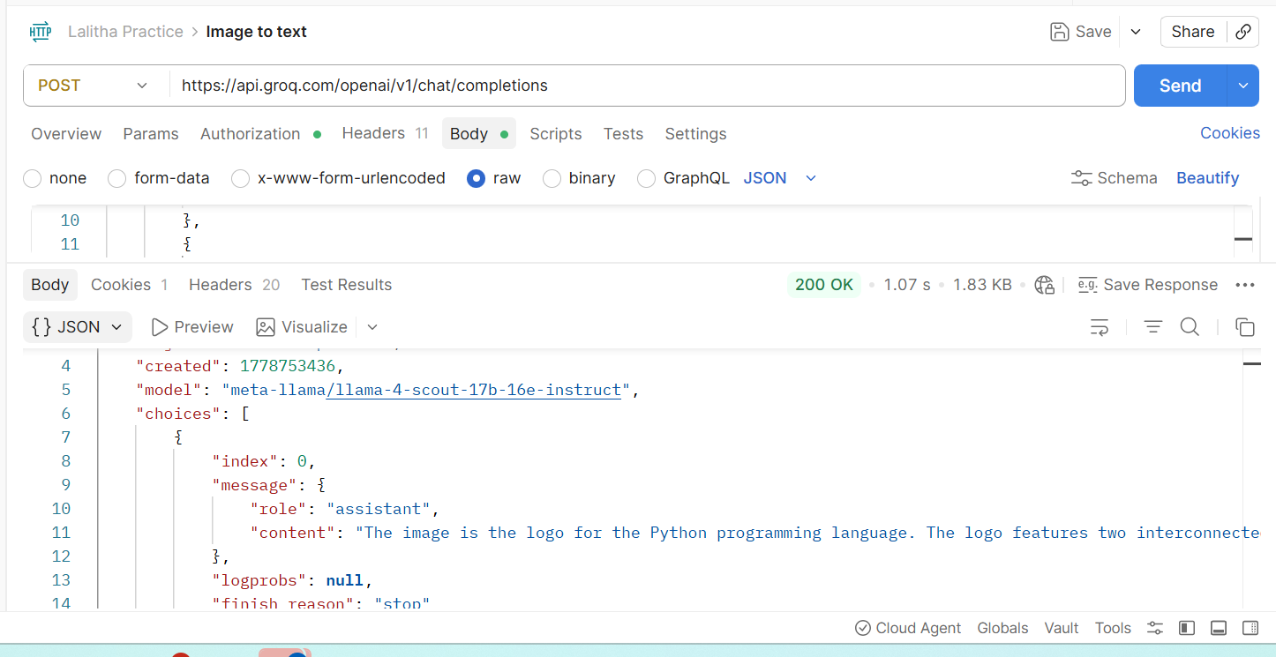
Faced access issue with image URLS . Other than that able to get the response.

